**Timeline: Chess in Python (Terminal)**

Total time spent: __ hours

# 11/10/2022

## Chess 1.0

### 2pm to 10pm (8 hours)

1. Started from scratchText

   Description automatically generated
2. Attempt at using usual chess notations
3. Was able to move pawns, use pawn to capture pawnText

   Description automatically generated

## Chess 2.0

### 10pm to 2am (4 hours)

1. Made an entirely new version using different way of inputting moves to make it easier to code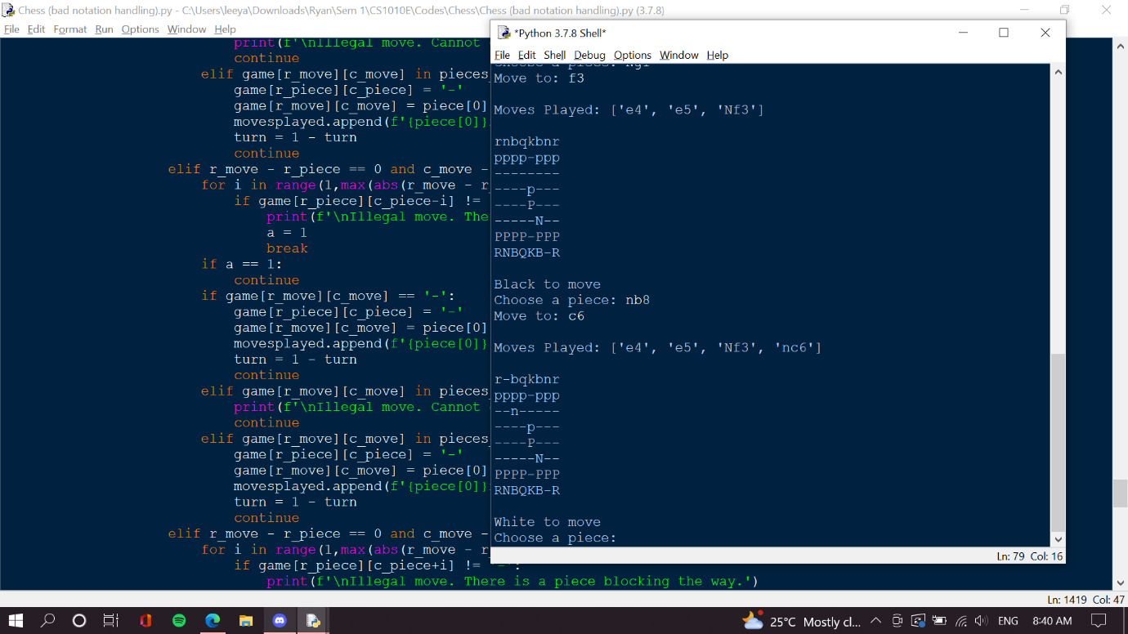

# 12/10/2022

## Chess 2.0

### 7am to 11pm (4 hours)

1. worked on pawn, knight movement and capturesText

   Description automatically generated

### 6pm to 9pm (3 hours)

1. Added bishop, rook movement and captures

# 13/10/2022

## Chess 2.0

### 7am to 8:30am (1.5 hours)

1. Added queen, king movement and captures

## Chess 2.1

### 3pm to 7pm (4 hours)

1. Made a new copy to try code cleaning for optimisation
2. Reduced from 1500 lines to 500 lines. The code had if turn == 0 and turn == 1 indicating the different turns and their legal moves. However with some simple lists like side = [1,-1], could use side[turn] to indicate different turns and their legal moves, which cut code in half

### 9pm to 11pm (2 hours)

1. Further reduced from 600 lines to 400 lines. Last step was cleaning up the code for pawn movement, which needed some simple math involving side[turn] as well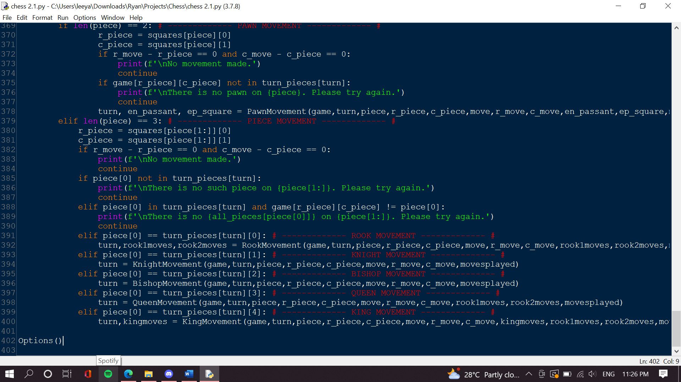
2. There are now functions for movement for every piece that takes in many argumentsText

   Description automatically generated
3. Code looks very neat :)

### 11pm to 11:30pm (0.5 hours)

1. Making this word document

# 14/10/2022

## Chess 2.2

### 7:30am to 8am (0.5 hours)

1. New version to try check and checkmate
2. Separated legal knight movement and made it its own functionText

   Description automatically generated
3. Managed to retrieve enemy king’s positionText

   Description automatically generated

### 2:00pm to 5pm (3 hours)

1. Trying out kings at either 4 corners and making pieces check king

## Chess 2.2.1

### 5pm to 6:30pm (1.5 hours)

1. New chess file – trying to optimize the code for when king is in corner as it was hardcoded in 2.2
2. Successfully optimized code with some math. Original was 4 times longer.A screenshot of a computer screen

   Description automatically generated
3. Made it so pieces can capture the pieces giving the check to remove check event

## Chess 2.2.2

### 7:30pm to 9:30pm (2 hours)

1. Made a new version to try general directions instead of hardcoding
2. Successfully did CheckRook, CheckBishop, CheckPawnA picture containing timeline

   Description automatically generated

### 10:30pm to 11pm (0.5 hours)

1. Finished CheckKnight with efficient code. (536 lines of code total)Text

   Description automatically generated

# 17/10/2022

## Chess 2.2.2

### 10pm to 1am (3 hours)

1. Fixed King movement, i.e. King cannot move to a spot where an enemy piece sees it. A screenshot of a computer screen

   Description automatically generated
2. King cannot move in front of enemy king
3. Made pinned piece
4. Remaining: Checkmate, Stalemate

# 18/10/2022

## Chess 2.2.2

### 7am to 8:30am (1.5 hours)

1. Cleaned king movement, allowed checking from castling, prevent castling if it puts own king in check. 650 linesText

   Description automatically generated

### 10am to 11am (1 hour)

1. Fixed pinned piece